**Exp No 8**

8.Practice Queries using Aggregate functions, Group By, Having Clause and Order by Clause.

1.

*select *from customersdata;*

*select min(age) as minage from customersdata;*

*select fname from customersdata where age = 18;*

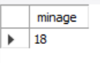

*select max(age) as maxage from customersdata;*

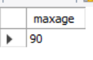

*select fname from customersdata where age = 90;*

*select count(age) as total_customersdata from customersdata;*

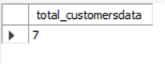

*select count(*) from customersdata;*

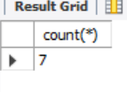

*select avg(age) as average_customersdata from customersdata;*

*select sum(age) from customersdata*;

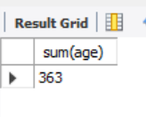

2.GROUPBY

*SELECT COUNT(CustomerID), Country*

*FROM Customers*

*GROUP BY Country*

*ORDER BY COUNT(CustomerID) DESC;*

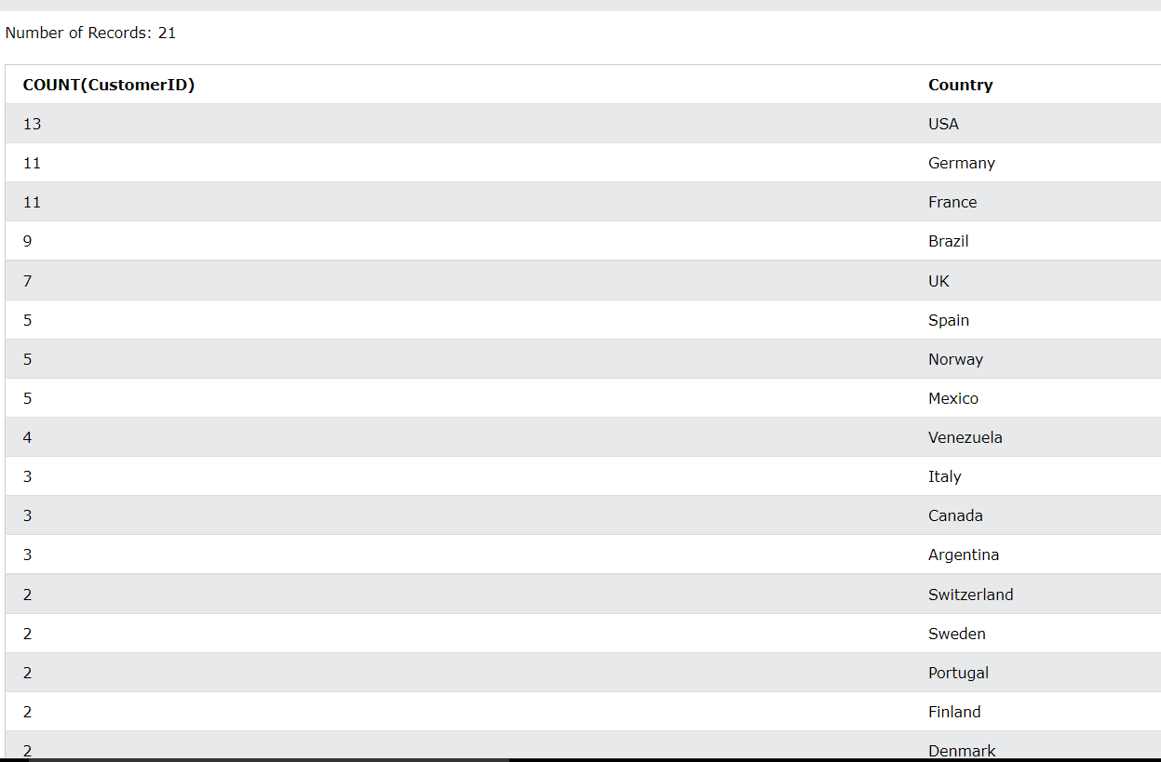

*3.*HAVING CLAUSE

*SELECT COUNT(CustomerID), Country*

*FROM Customers*

*GROUP BY Country*

*HAVING COUNT(CustomerID) > 5;*

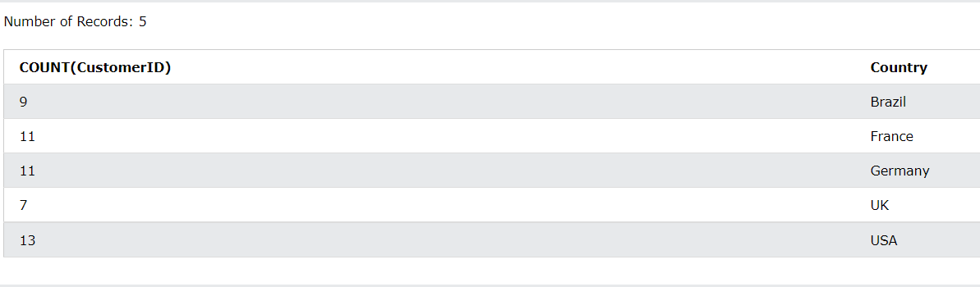

*4.ORDERBY*

*SELECT COUNT(CustomerID), Country*

*FROM Customers*

*GROUP BY Country*

*HAVING COUNT(CustomerID) > 5*

*ORDER BY COUNT(CustomerID) DESC;*

